**Name:** Fazira Harahap (Zizi)

**Student ID:** 22684855

**COMMIT MISTAKES**

Dear Professor,

I apologise for my mistakes in committing files to the wrong repository several times.

The evidence shows that the commits have been made since 7 May 2025.

I appreciate your understanding.

**Proof_of_1_Mistaken_Commits** (8/05/2025 – 15/05/2025)

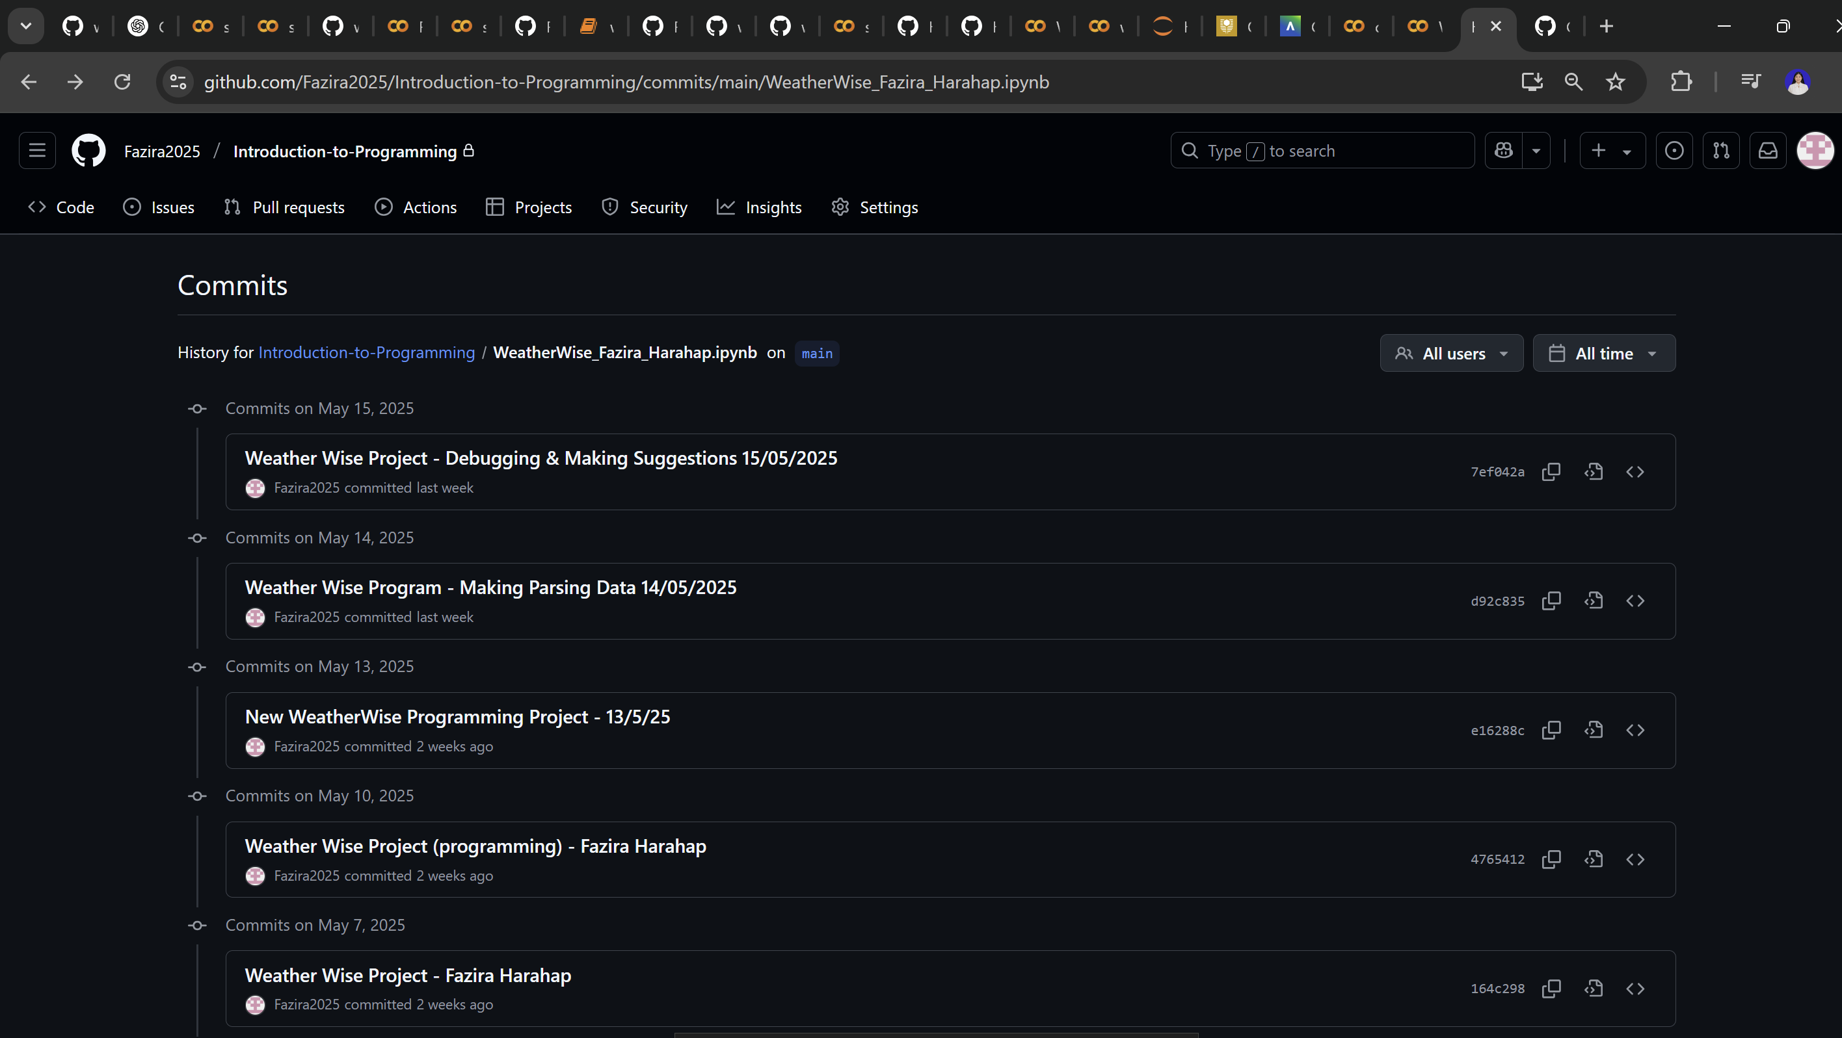

**Commit 1 –** 07/05/2025 (creating menu with print ())

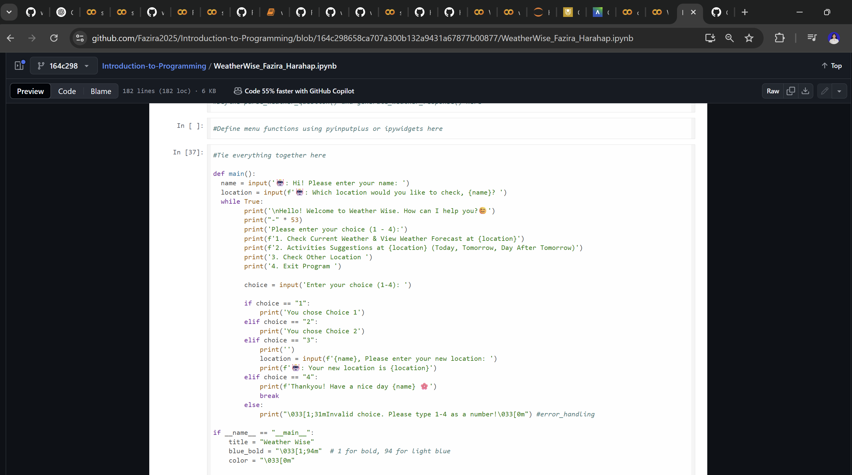

**Commit 2 –** 10/05/2025 – Fazira Harahap (parsing with API)

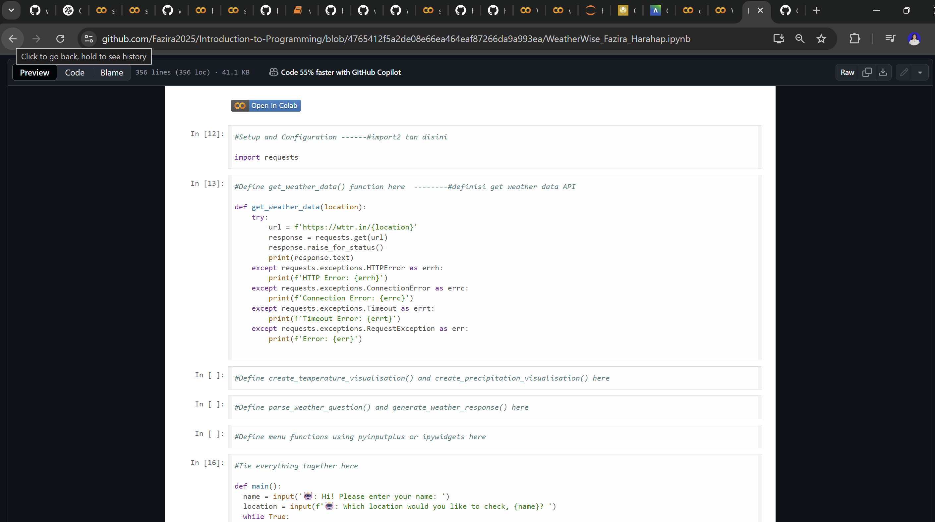

**Commit 3 –** 13/05/2025 (parsing with API JSON & get weather emoji)

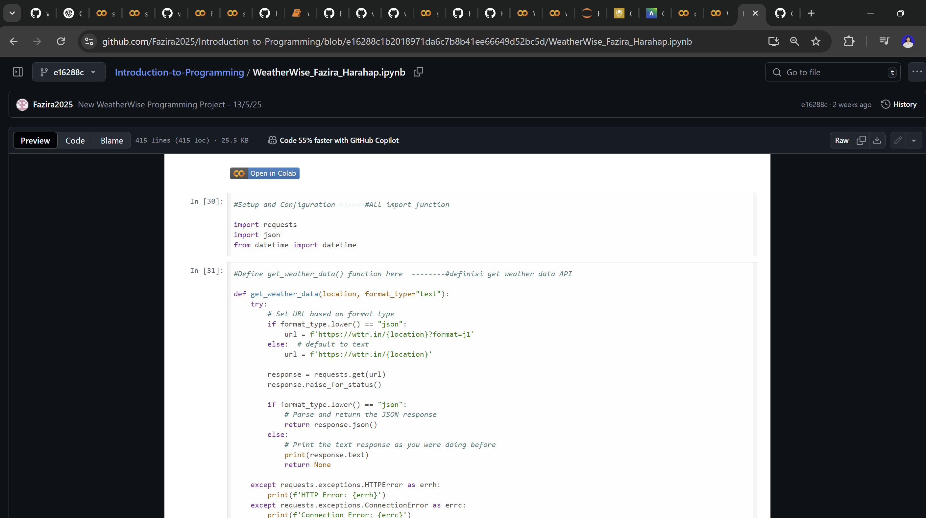

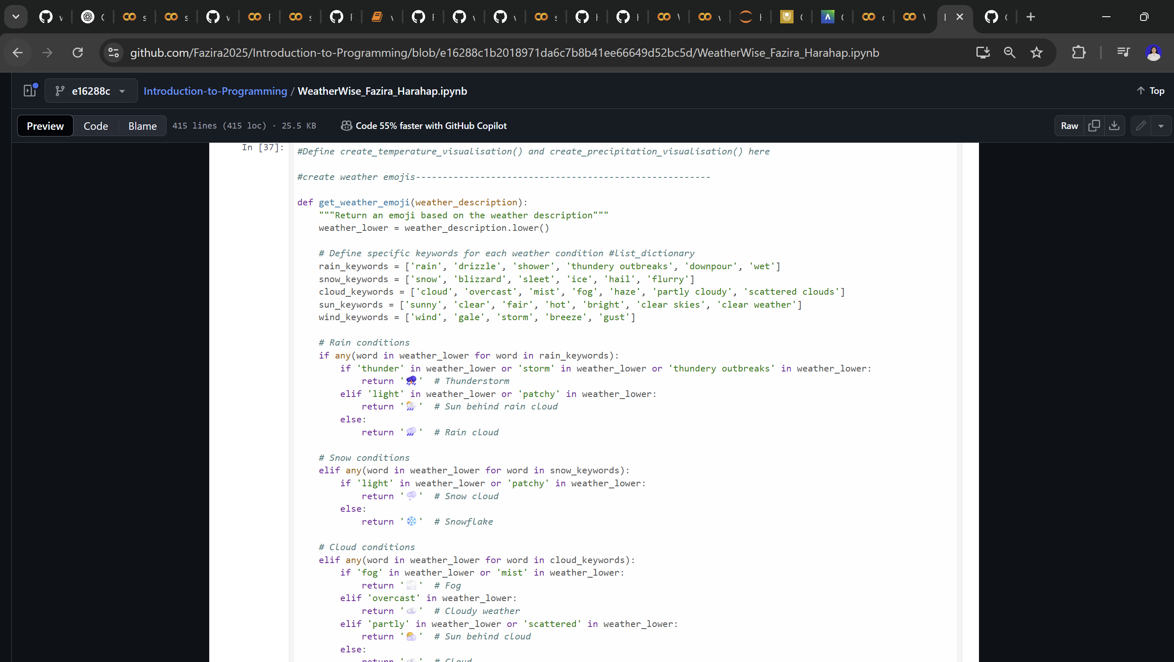

**Commit 4 –** 14/05/2025 (parse weather question)

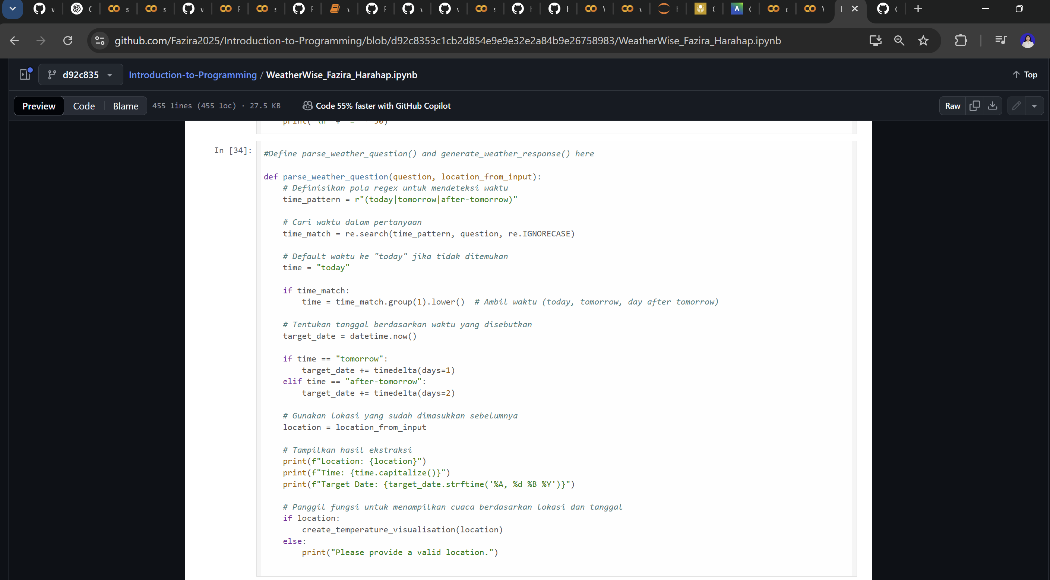

**Commit 5 –** 15/05/2025 (generate weather data & create visualisation)

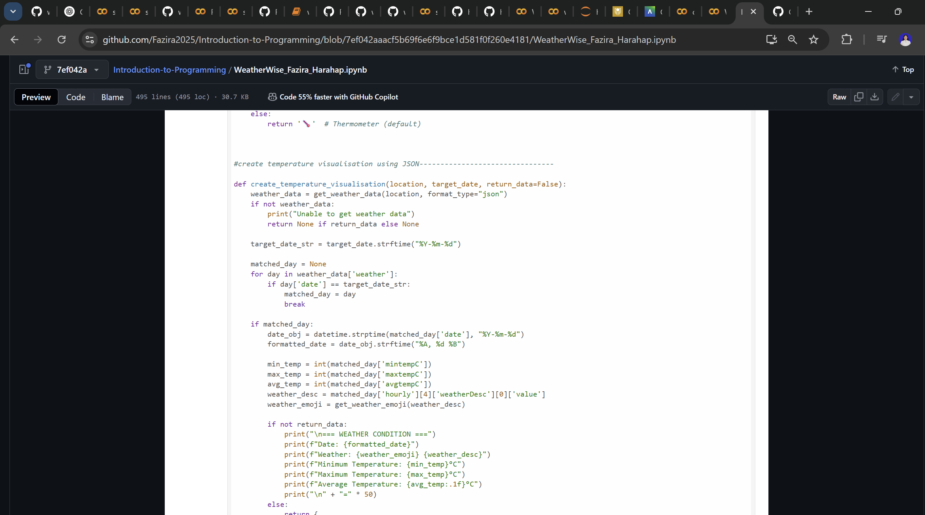

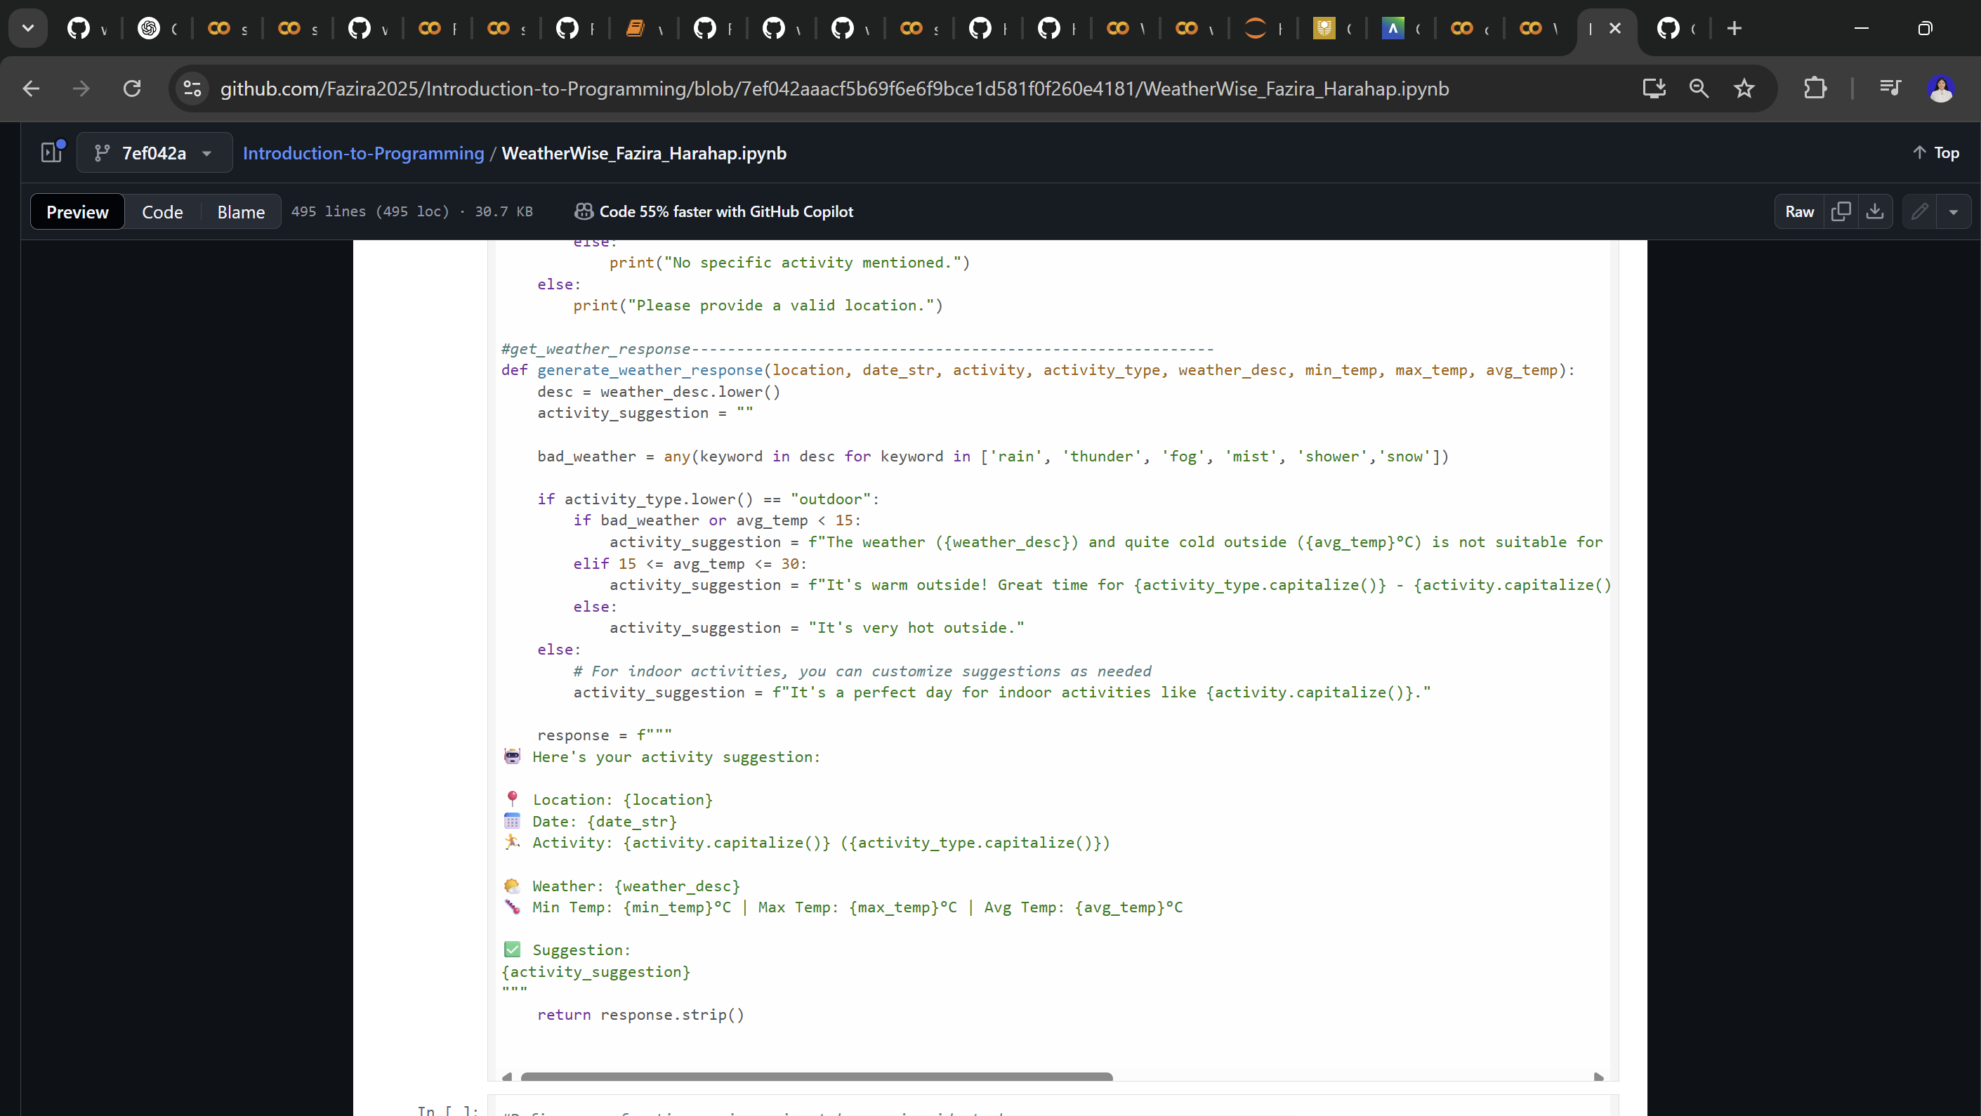

**Proof_of_2_Mistaken_Commits** (22/05/2025 – 23/05/2025)

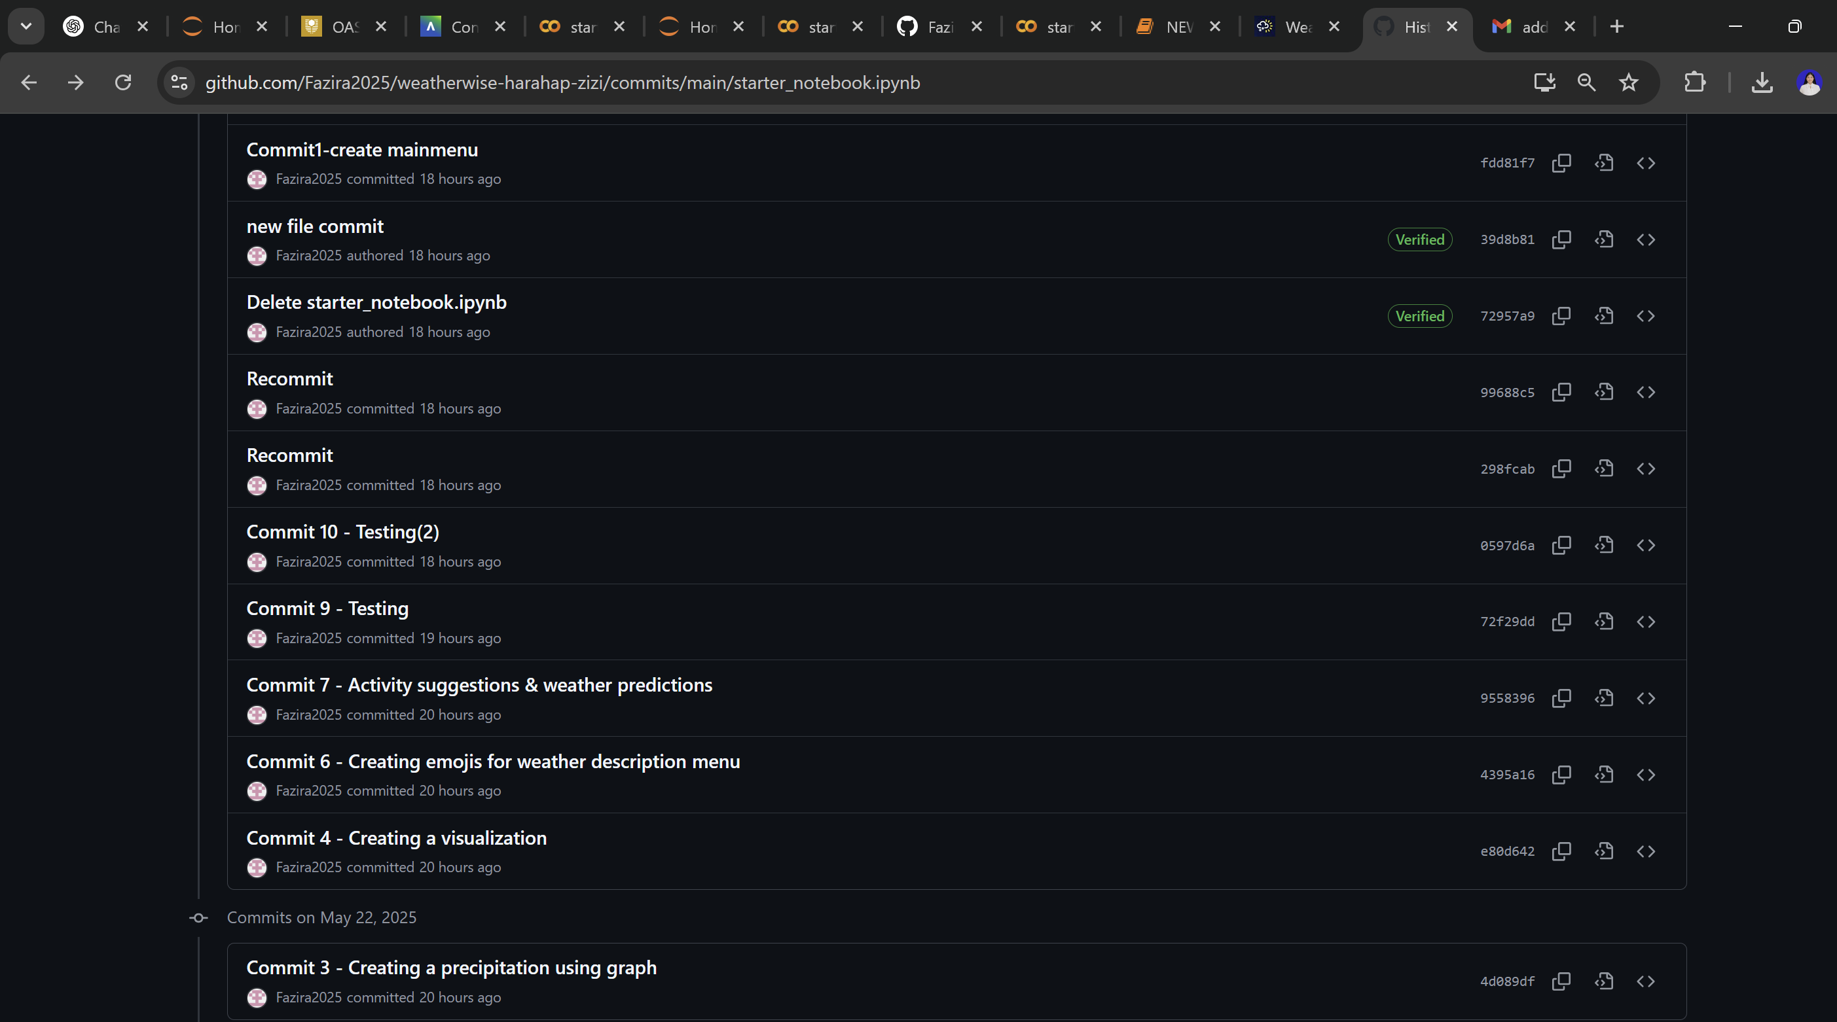

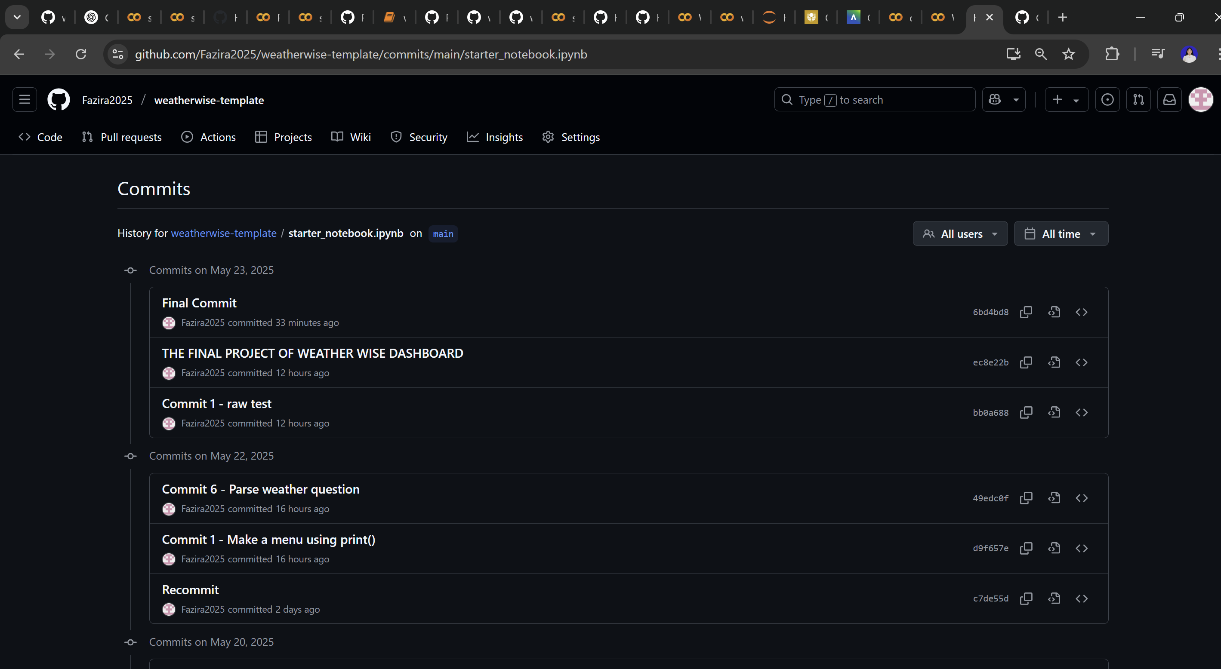

**Commit 6 –** (create visualisation using graph)

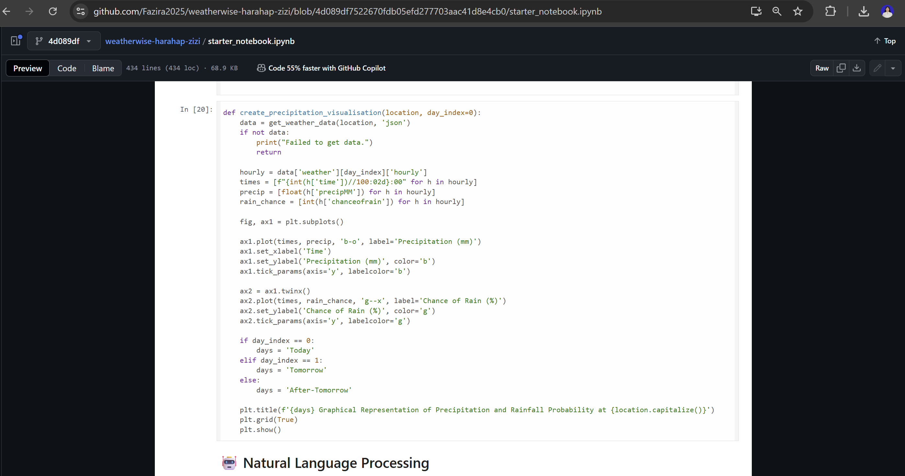

**Commit 7 –** (create precipitation)

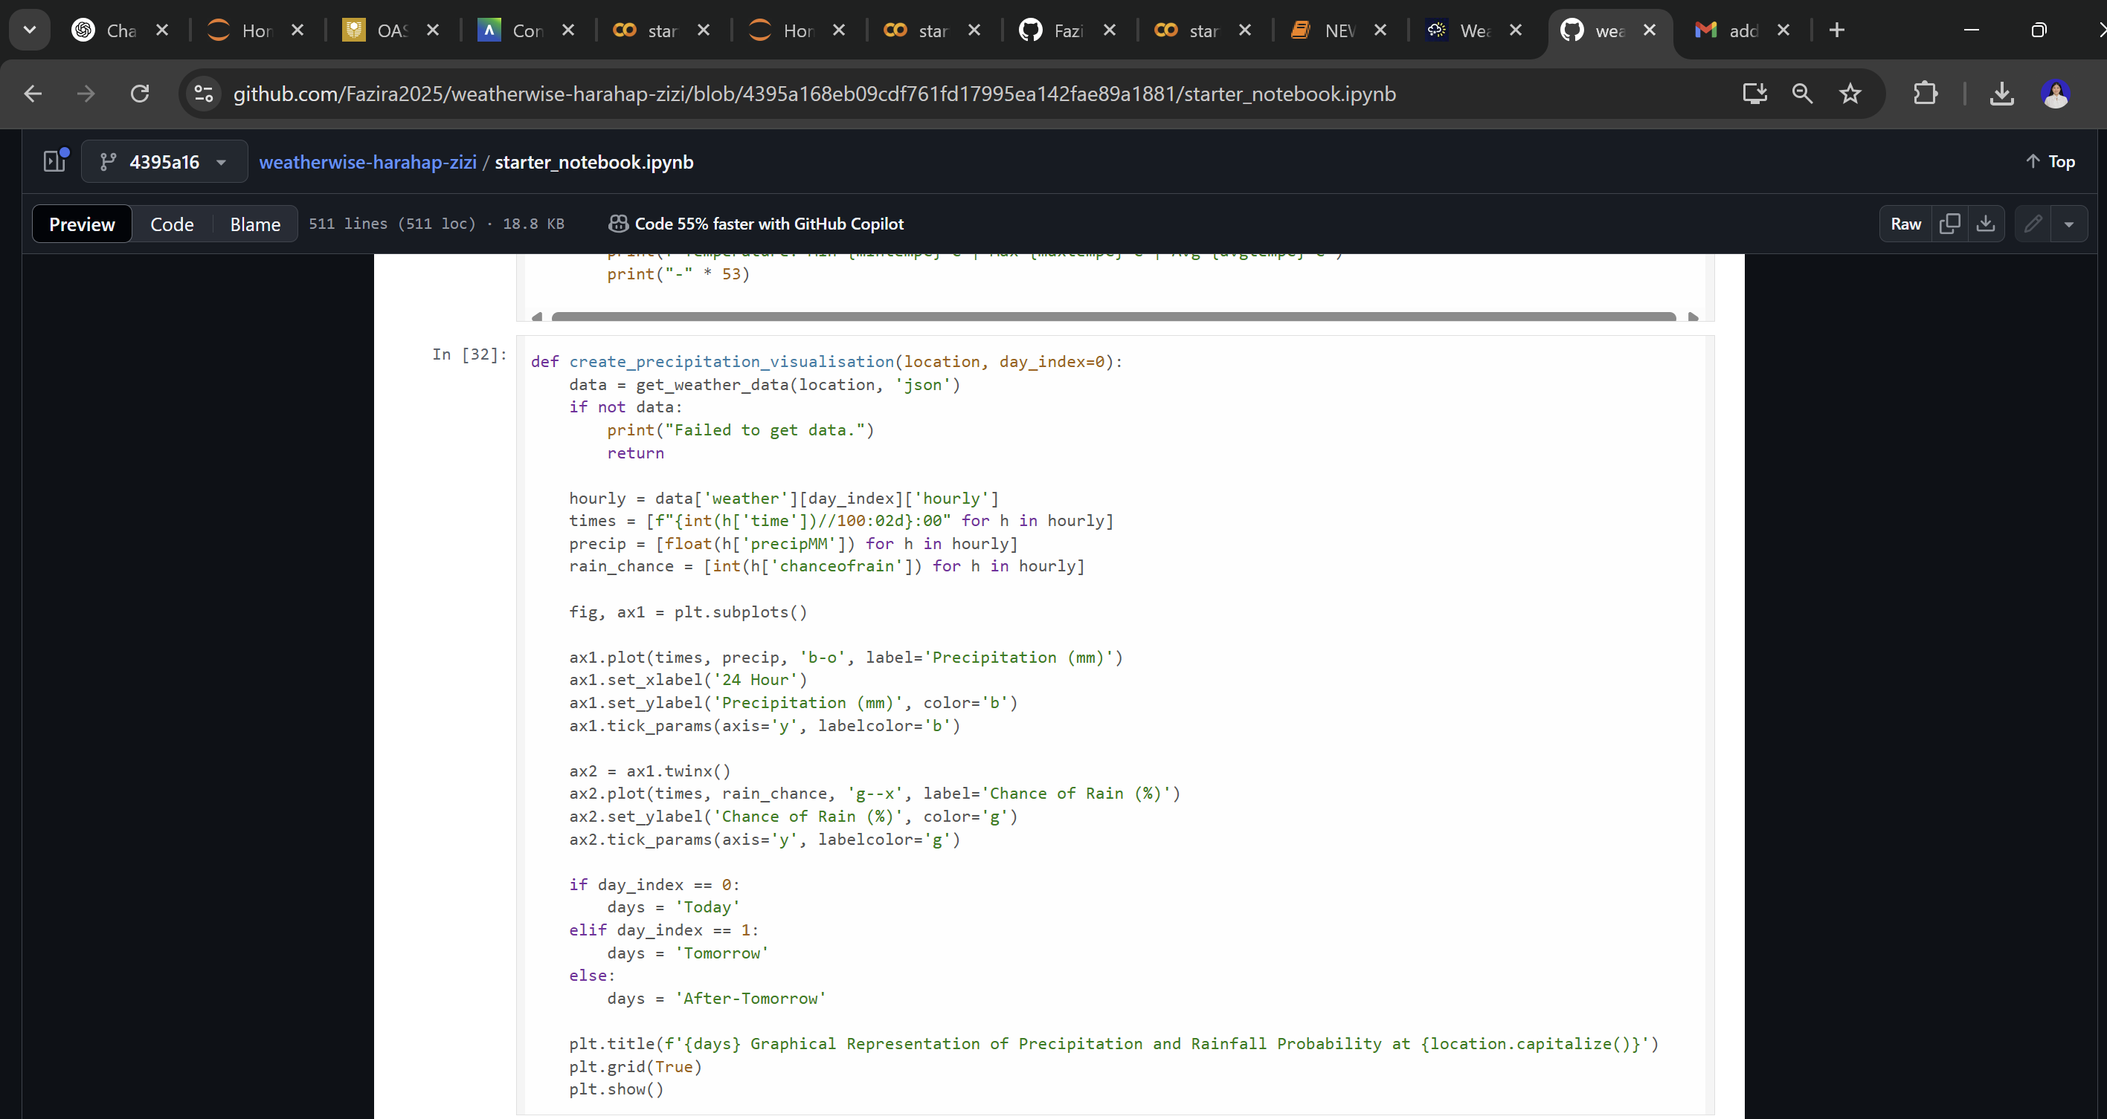

**Commit 8 –** (activity suggestions & weather predictions)

